Data Intake Report

Name: Pranav Walia

Report date: July 5

Internship Batch: LISUM 10: 30

Version:<1.0>

Data intake by: Pranav Walia

Data intake reviewer: Pranav Walia

Data storage location: github

**Cloud and API deployment**

**Step 1: Machine Learning model for price data set**

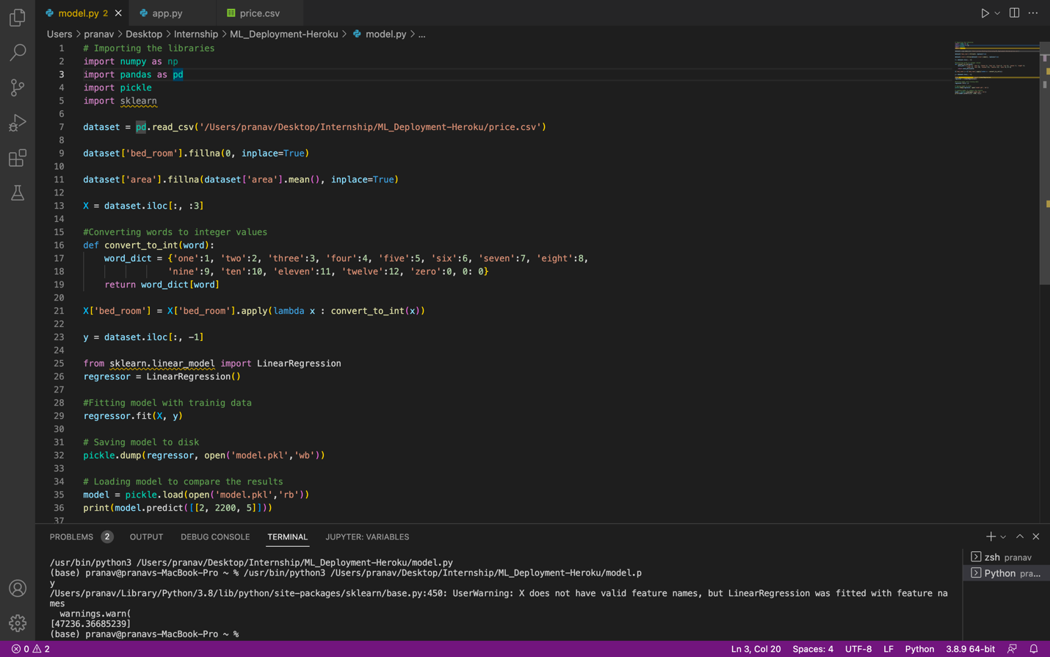

**Step 2: Creating the web app**

**Step 3: Committing code in online repo**

**GitHub- https://github.com/pranav611/Heroku-deployment-.git**

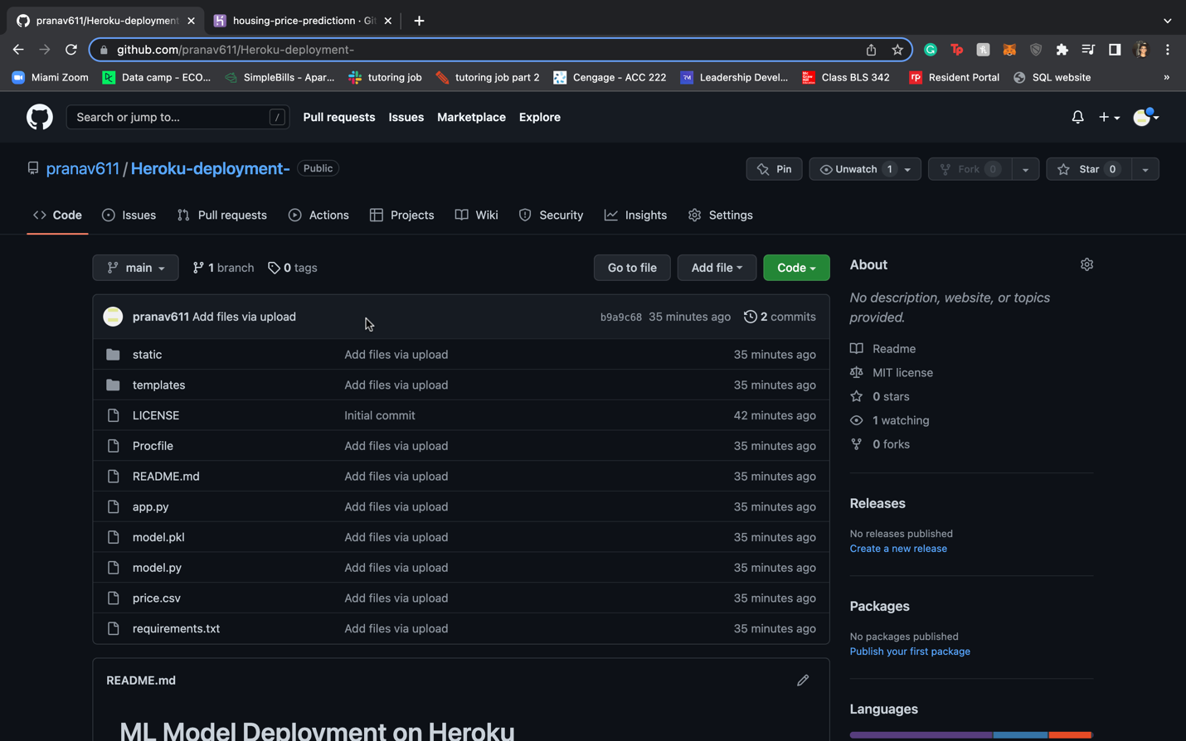

**Step 4: Heroku deployment**

